Step 1: Read the article and complete # 1-4. Use full sentences where necessary.
https://foodcrumbles.com/chemical-formulas-food/
- Ascorbic Acid is chemically C₆H₈O₆ Explain what the letters and numbers mean.
Type here

- How is a chemical formula similar to an ingredients list?
Type here

- What is a disadvantage of using chemical formulas for recipes?
Type here

- Why do some chemical formulas have numbers after the element and some do not?
Type here

Step 2: Convert the recipe from chemical formulas to ingredients. Use the article listed above as well as the NCBI Pub Chem Compound search tool (click here). Be sure to put both the chemical name and the standard ingredient name as we know it in the kitchen.
C₁₂H₂₂O₁₁ | Type here
NaCl | Type here
C₁₂H₁₉Cl₃O₈ | Type here
C₈H₈O₃ | Type here
C₆H₈O₆ | Type here

Extra Credit!
NaHCO₃ + KC₄H₅O₆ | Type here + | Type here | = Type here

Step 3: Use the NCBI Pub Chem Compound search tool (click here) to find the chemical formulas for the selected ingredients on the label shown below and put them in the chart provided.

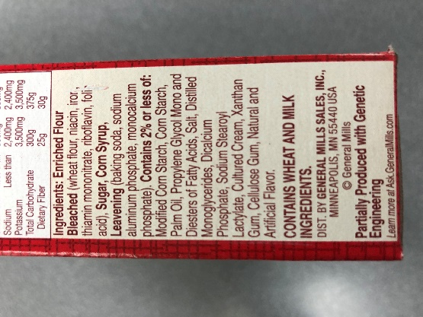 | Ingredient | Chemical Formula
 | Palm Oil
 | Dicalcium Phosphate
 | Corn Starch
 | Xanthan Gum
 | Corn Syrup
 | Folic acid
 | Niacin
 | Iron

