Choosing the Best Cookie

This article is a portion of a blog post. To read the rest of the blog post please visit the site at http://cowgirlkacy.hubpages.com/hub/Baking-Chocolate-Chip-Cookies-for-the-County-Fair#
Cool your cookies on a flat surface, like a clean countertop. Don’t use a rack, because the rack will leave marks on the bottom of the cookies. To prevent the cookies from sticking to the cooling surface, flip them over once they are cool enough to touch.
Once the cookies are baked and cooled completely, it’s time to select the ones you’ll take to the fair. Usually a class calls for three cookies. These three cookies need to be as similar as possible.
Observe your cookies looking for three that are the same size and shape. Even if you used a cookie scoop, you’ll find there is a lot of variation between cookies. Usually, it’s easy to find two cookies that match, but hard to find the third. Just start mixing and matching and eventually you’ll end up with several groups that are possibilities.
At this point, flip the cookies over to check the color of the bottom. This needs to be uniform as well.
When you find your three ‘perfect’ cookies, package them as is specified in the class list. Usually this means place them on a small Styrofoam plate and put the plate into a Ziploc bag. Attach your entry tag, and you’re ready to go!
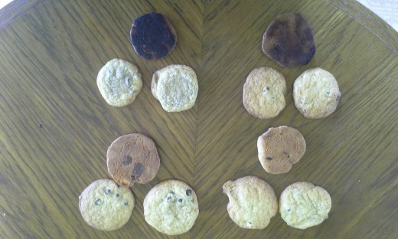
Three possible samples of cookies, exaggerated slightly. The bottom left sample would be the ideal one to take to a fair.
Source: Author Photo

The Judging Process
When your baking is judged, the judge will first observe your cookies for uniformity, color and texture. To view the texture, they will break one cookie in half and observe the inside to see if it’s fully cooked. Then they will taste one half of the cookie. Taste is the most important part of the scorecard. If your cookie is the best, you’ll usually be awarded a ribbon, and sometimes prize money. Sometimes the judge will write a note on the back of your entry tag with ways you can improve. If you practice every time you bake cookies, you’ll find you have a winning entry in no time.

